ELEVATE LABS

TASK – 4 CYBER SECURITY

Setup and Use a Firewall on Windows/Linux

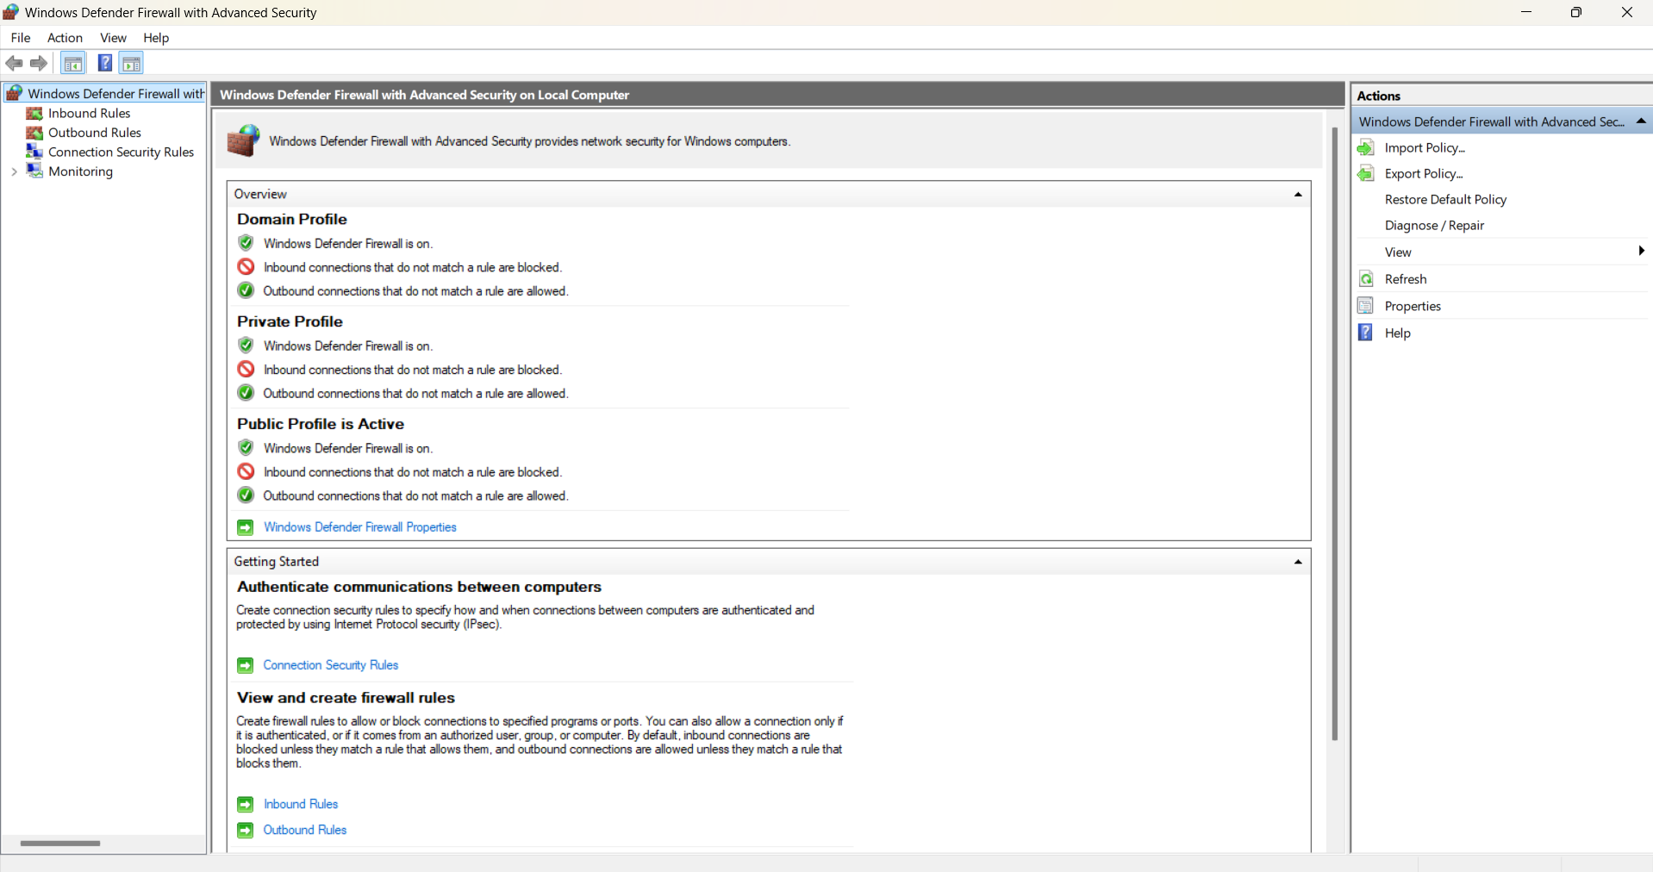
Open Windows Defender Firewall

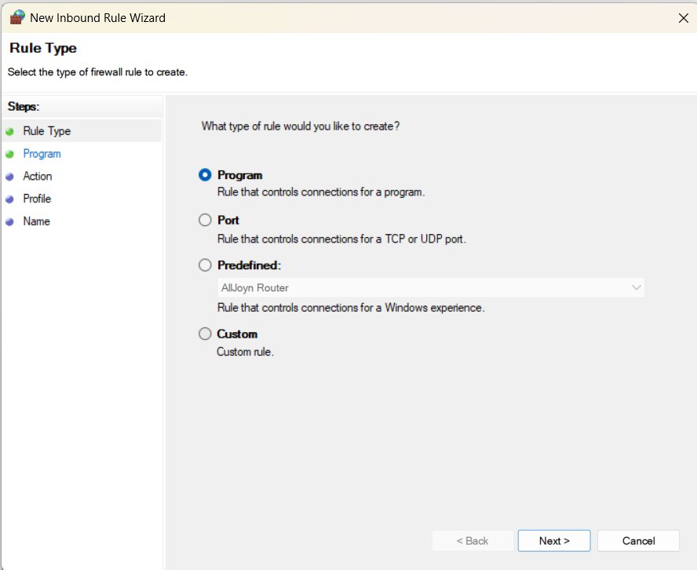
Navigate to "Inbound Rules" and select "New Rule."

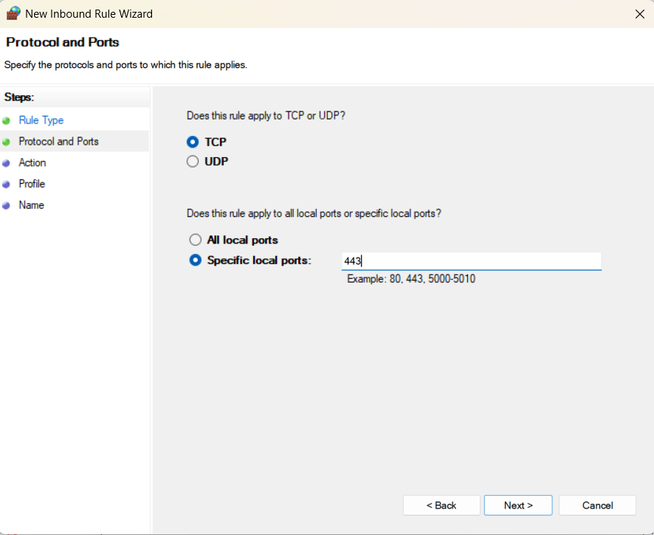
Choose "Port," select TCP, and specify port 443.

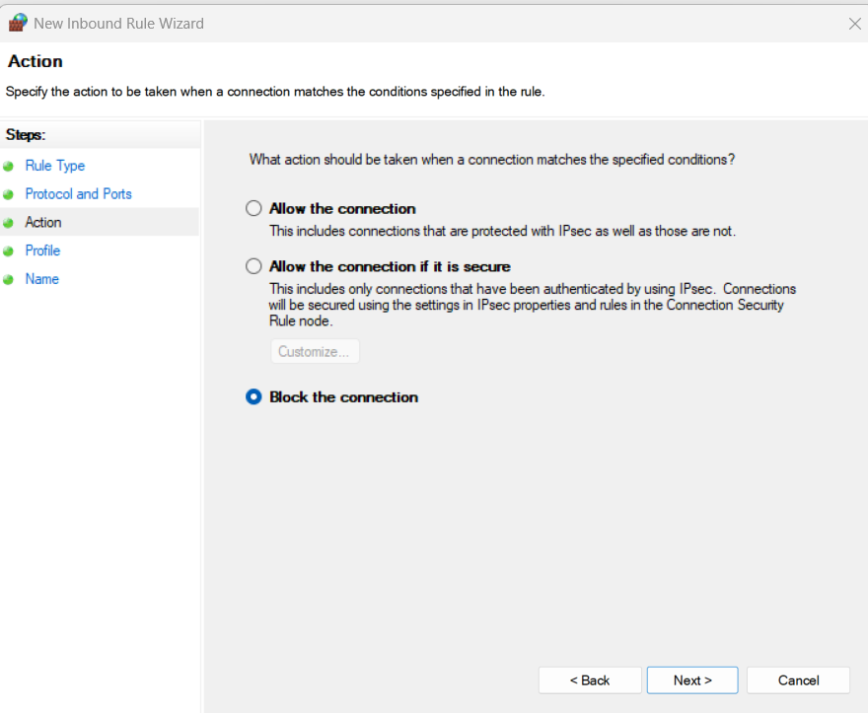
Test by attempting to access an HTTPS site (e.g., https://example.com) and confirm it’s blocked.

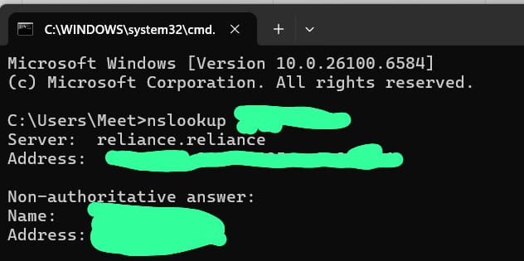
Identify the IP address of the target website to blocked (e.g., via ping example.com).

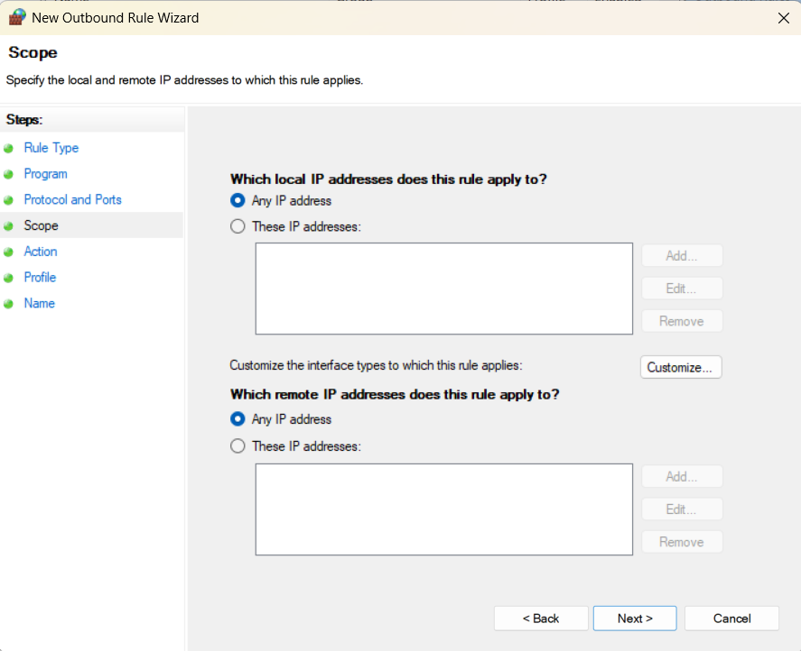
Go to "Outbound Rules" and create a new rule.

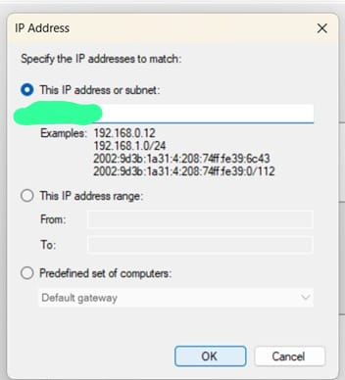
Select "Custom," enter the website’s IP, and block the connection.

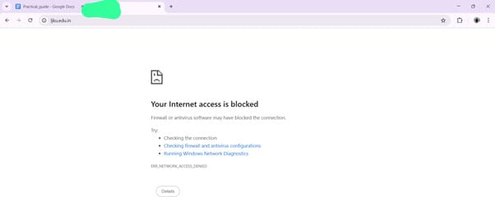
Verify by trying to access the website and ensuring the connection fails.

Analysis:
By accessing the advanced settings in Windows Defender Firewall, we created inbound rules to block port 443 and outbound rules to deny connections to a specific IP. These rules were verified through browser and command-line testing to confirm their effectiveness.

Conclusion:
This task demonstrated how firewall rules can be tailored to enhance system security. Proper configuration of Windows Defender Firewall helps prevent unauthorized access and control unwanted network communication.

